How to Retrieve Records from the Enter Professional Development Activity Form

- Go to the Admin side of Sullnet. | 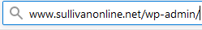

- Login.  The password is *****v**01! (Asterisks are placeholders for the password you chose at the outset of Sullnet.) | 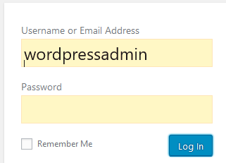

- On the left panel, go to Forms.

- Hover over the name of the form of interest (e.g., Enter Professional Development Activity) to expose the submenu, and then click View Submissions. | 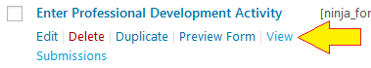

- In the upper left, click the drop arrow of Bulk Actions and select Export. When you click Apply, the utility pops an Excel download dialog. You know what to do from there.  - You must select at least one item in the list.  - You can search for a given instructor, select only her/his records, and then download only those records. This is how you download a given instructor’s transcript.  - There are beginning and end date selectors that can define searches by time. | 