 | ASSESSMENT PLAN GUIDELINES  Planning and Evaluation Coordinating Council (PECC)
Name of Program or Unit: Insert name of program or unit and presenter(s)  Type of Program or Unit (Check one)  ☐ Administrative Support Services (SACSCOC 7.3)  ☐ Educational Programs (SACSCOC 8.2a)  ☐ General Education (SACSCOC 8.2b)  ☐ Academic and/or Student Support Services (SACSCOC 8.2c)  Review Date: Insert date of PECC presentation  Presenter: Insert name(s) of presenters | 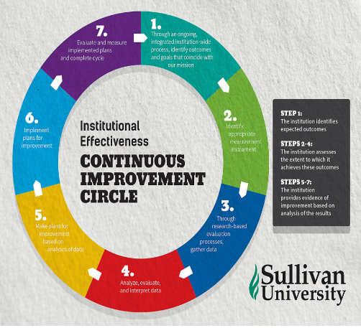

Assessment Plan Evaluation

Alignment of Mission

Culture of Continuous Improvement
EXPECTED OUTCOMES (Continuous Improvement Circle [CIC] Step 1)

METHODOLOGY FOR ASSESSMENT OF OUTCOMES (CIC Steps 2 & 3)

PLAN FOR IMPROVEMENT: (CIC Steps 4 & 5)

ASSESSMENT OF STEPS TAKEN TO PRODUCE IMPROVEMENT “Close the Loop” (CIC Steps 6 & 7)

APPENDIX: ASSESSMENT DATA (CIC Step 3)

Alternative Formats for Culture of Continuous Improvement
Expected Outcomes | Method for Assessment of Outcomes | Plan for Improvement | Assessment of Improvement Steps
1.
2.

- Expected Outcome #1
Methodology for Assessment of Outcomes
Plan for Improvement
Assessment of Steps Taken to Produce Improvement “Close The Loop”
- Expected Outcome #2
Methodology for Assessment of Outcomes
Plan for Improvement
Assessment of Steps Taken to Produce Improvement “Close The Loop”

Resources for Preparing Assessment Plan
General  - SACSCOC 2018 Principles of Accreditation  - SACSCOC 2018 Accreditation Resource Manual  - Key Compliance: Student Achievement  Alignment of Mission  - PECConomics: Alignment of Mission  - Academic Illuminator: Alignment of Mission  Culture of Continuous Improvement (CoCI)  - SACSCOC Institutional Effectiveness  - CoCI High Impact Practices  - CoCI Examples (Password: SUL_CIC) | Expected Outcomes  - Measurable & Non-Measurable Outcomes  - Direct and Indirect Measures  - CoCI High Impact Practices - Outcomes  - S.M.A.R.T. Objectives  - Language and Syntax of Outcomes  Assessment of Outcomes  - Examples of Good Assessment Practice  - Model of Administrative, Academic & Student Service Assessment  - Triangulation of Data  - Data Visualization Guide  Improvement  - Closing the Loop

