 | BALANCED ASSESSMENT SCORECARD  Planning and Evaluation Coordinating Council (PECC) Rubric

Program/Department/
Support Unit reviewed: ______________________________
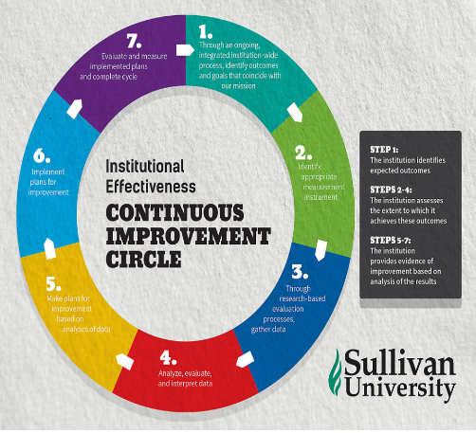
Date of Review: ___/___/____
Reviewers: 1. _____________________________________
2. _____________________________________
3. _____________________________________
FEEDBACK | STRENGTHS:
FEEDBACK | 1. _______________________________________________________________  2. _______________________________________________________________  3. _______________________________________________________________
FEEDBACK | AREAS FOR IMPROVEMENT:
FEEDBACK | 1. _______________________________________________________________  2. _______________________________________________________________  3. _______________________________________________________________
ASSESSMENT INDICATOR | Recommended Immediate Action  (1) | Developmental Phase  (2) | Recommended Annual Review  (3) | Recommended Biennial Review  (4) | Rating
Assessment Plan Evaluation
The department/support unit systematically executes assessments as indicated in its plan using an evidence-based approach consistent with the SU Continuous Improvement Circle (CIC) methodology. | No evidence exists. | Evidence exists, but several aspects are missing or need elaboration to determine if it operates as intended. | Assessment plan with relevant evidence showing support for action. The plan or core evidence has changed within the past 2 years. | Assessment plan with relevant evidence showing support for action has been implemented successfully for 2 years.
Alignment of Mission
- MISSION
I. The department/support unit has a clearly-defined mission statement that aligns with the SU mission. | The mission statement is not clearly defined and/or is not well-aligned with the SU mission. | The mission statement requires further definition and alignment with the SU mission. | The mission statement is clearly-defined and aligned with the SU mission has been modified within the past 2 years. | The mission statement is clearly-defined and aligned with the SU mission has not been modified within the past 2 years.
Culture of Continuous Improvement
- EXPECTED OUTCOMES (CIC Step 1)
II A. The department/support unit’s outcomes are comprehensive and aligned to its mission and functions. | Outcomes are not well-aligned to the mission and major functions. | Outcomes include some of the unit’s major functions, but not others. | Outcomes include the unit’s major functions and have been modified in the past 2 years. | Outcomes include the unit’s major functions and have not been modified in the past 2 years.
II B. The department/support unit’s outcomes are written using measurable terms. For student learning outcomes, these terms are at the appropriate academic level. | The outcomes are not written with measurable and/or level-appropriate action verbs. | Some of the outcomes are written with measurable and/or level-appropriate action verbs. | Nearly all outcomes are written with measurable and level-appropriate action verbs. | All outcomes are written with measurable and level-appropriate action verbs.
II C. The department/support unit’s outcomes and targets are validated for appropriateness. | The outcomes and targets have not been validated. | The outcomes and targets have been validated by internal, but not external, expertise. | The outcomes have been validated by one outside research, expert, advisory committee and/or accrediting body. | The outcomes have been validated by multiple outside research, experts, advisory committees and/or accrediting bodies.
ASSESSMENT INDICATOR | Recommended Immediate Action  (1) | Developmental Phase  (2) | Recommended Annual Review  (3) | Recommended Biennial Review  (4) | Rating
- METHODOLOGY FOR ASSESSMENT OF OUTCOMES (CIC Step 2)
III. A. The department/support unit collects data for each outcome utilizing a program-appropriate methodology. | Outcomes are not assessed using a program-appropriate methodology. | Some outcomes, but not others, are assessed using a program-appropriate methodology. | All outcomes are assessed using a program-appropriate methodology. | All outcomes are assessed using multiple/advanced program-appropriate methodologies with triangulation of data.
III. B. The department/support unit presents improvement-driving data for all outcomes across all locations/  pedagogical modalities. | The department/support unit does not present improvement-driving data. | Improvement-driving data is presented for some outcomes or for some locations and modalities, but not others. | Improvement-driving data is presented for all outcomes across all locations and modalities. | Multiple years of improvement-driving data is presented for all outcomes across all locations and modalities.
III. C. Whenever appropriate and feasible, data should be represented in graphical and/or tabular format, keeping text to a minimum. | Data are represented within blocks of paragraph text only. | A few data points are represented by tables. Much of the information is textual. | Important data are represented in graphical and/or tabular format with text explanations kept to a minimum. | Nearly all data are represented by user-friendly figures, charts, graphs and tables with text explanations kept to a minimum.
- PLAN FOR IMPROVEMENT (CIC Steps 4 & 5)
IV. A. The department/support unit presents actionable improvements based on analysis of data. | Actionable improvements based on analysis of data are not presented. | Some of the data are analyzed to drive improvements. | Actionable improvements are presented based on the analysis of data. | Actionable improvements are presented based on the analysis of data demonstrating clear data-to-improvement directionality.
- ASSESSMENT OF STEPS TAKEN TO PRODUCE IMPROVEMENT (CIC Steps 6 & 7)
V. A. Results of previous year’s plan for improvement are assessed to determine the plan’s success (“close the loop”) and to plan for future modifications or improvements. | No analysis of previous year’s improvement plan and data. | Previous year’s data are partially analyzed and reported. | Previous year’s improvement plan and data are analyzed and reported, and new plans are being formulated based on the previous year’s data. | Previous 2 year’s improvement plans and data have been analyzed and reported, with new plans formulated based on the previous year’s data.

